**►M**edium **A**ccess **C**ontrol **protocol：** Avoid collisions or re-transmit data if a collision occurs,

Internet

Offer each node a fair access to the channel. (Each device on the network gets a fair share of channel bandwidth on average.)

**►Bandwidth:** The amount of data that can be passed along a communication channel in a given period of time.**►Channel access methods**: MAC protocols follow different approaches for sharing the channel.

**Random Access**: Stations contend with each other without any centralized coordination. (Collisions are the norm)

A specific algorithm for resolving contention/reducing collisions once they happen.

resolve collision冲突: detect a collision and do something to fix it reduce collisions: reduce the odds for a collision to happen **Deterministic Access**: There is no contention – stations agree in advance (There are no collisions)

Different ways to agreeing, resulting in different MAC protocols:

Centralized: a unique entity decides on resource allocation Distributed: nodes agree by exchanging messages

**►ALOHA network:** Use the direct form of transmitting user information in a single high-speed packet burst in a shared wireless channel

**Channel access philosophy:** let collisions happen, detect when they occur and then try again.

Any station can send data at any time

If, while transmitting, any data is received concurrently, then there is a collision – will need to try again

**How to try again?**

Re-send data after a random duration called the Backoff period

Avoids repeated collisions.

The way this random choice is made influences the overall performance. **Vulnerability period**: The message transmitted at time t experiences a collision if any other message overlaps partially with its transmission.

If all messages have equal **length T**, then the **vulnerability period** is of size **2T**. **Throughput**: Suppose that the number of transmission attempts per frame duration *T* follows a Poisson distribution of *mean G*.

Thus, the probability of having *k* attempts during *T* is:

The probability of having no collision for the vulnerability period of *2T* is given by

Thus, the throughput is the number G of attempts during T that don’t experience any collision:

**提高ALOHA效率**: reduce the vulnerability period duration by synchronizing

All nodes are synchronized on a given slot duration of size *T*.

A transmission can only start at slot begin. → vulnerability period is reduced to *T*. **Throughput:**

**The number of transmissions E: ,**

**►C**arrier **S**ense **M**ultiple **A**ccess: The node has to sense the channel to detect an ongoing transmission

If the channel is **busy**, then she **defers** transmission; If the channel is **idle**, then she **transmits**

Whenever a node starts transmitting, it sends the **complete message.**

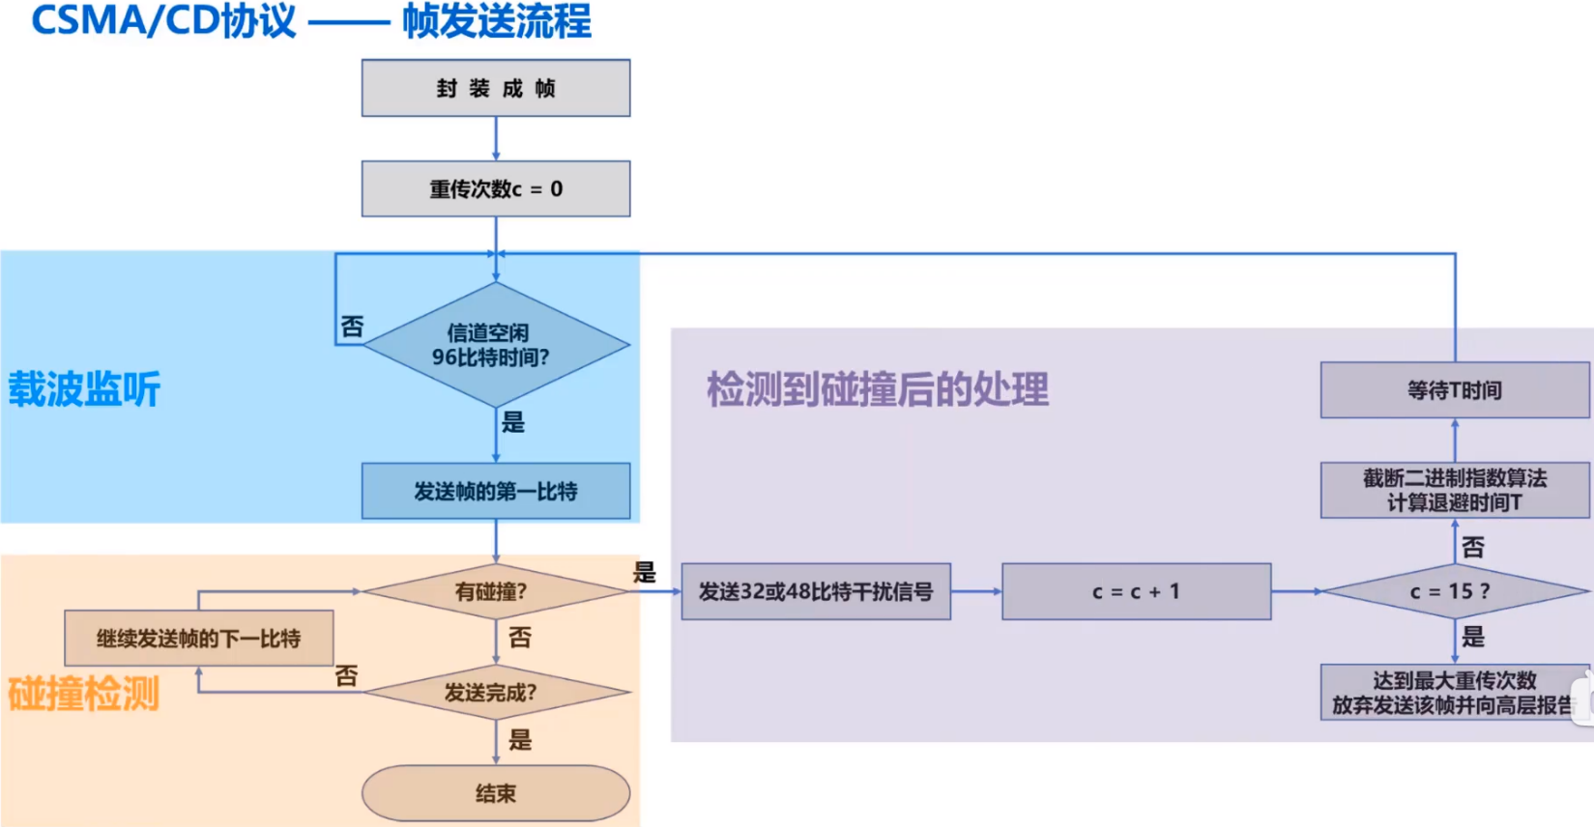

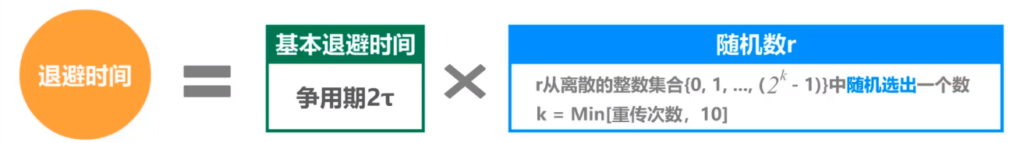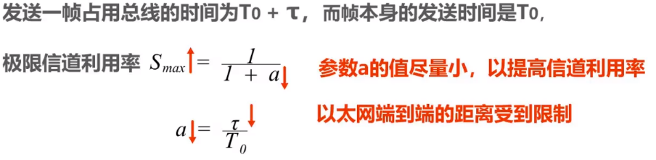

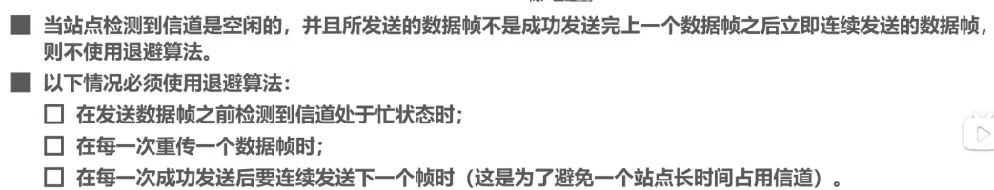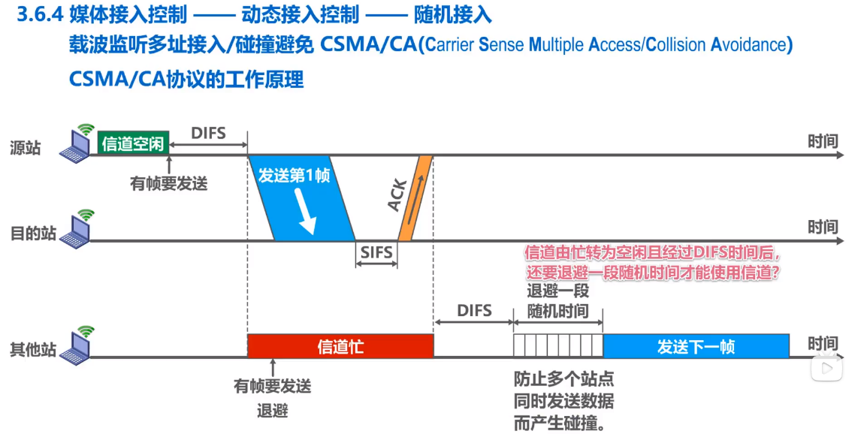

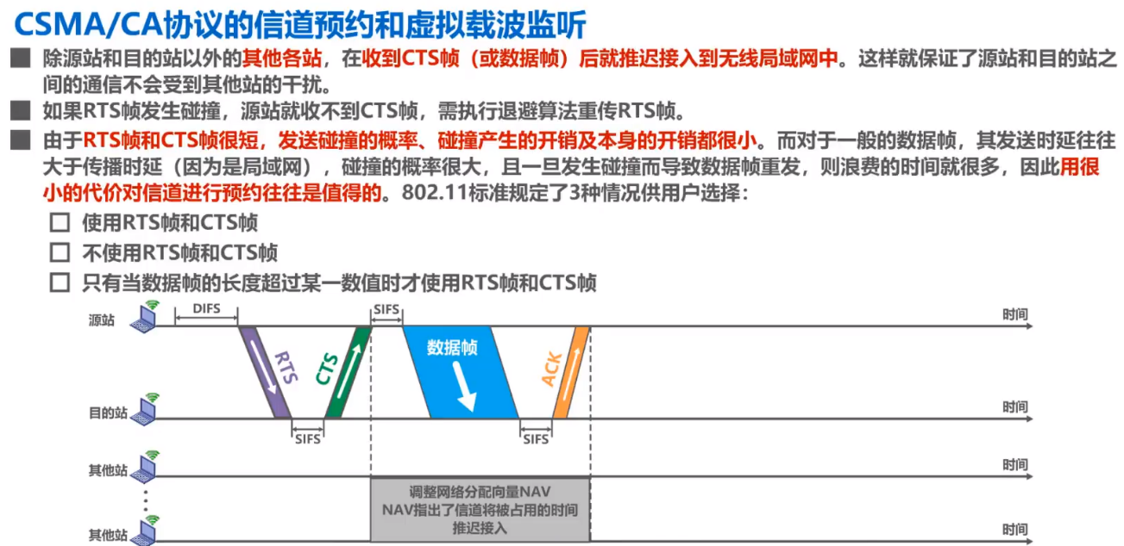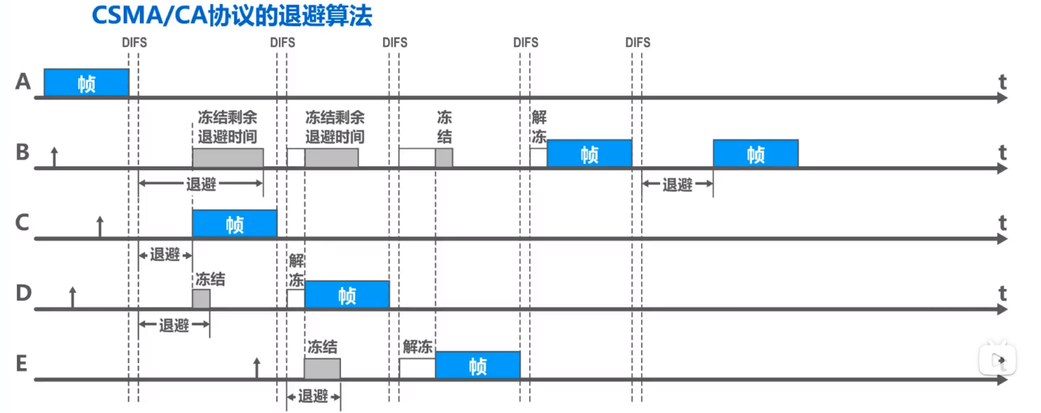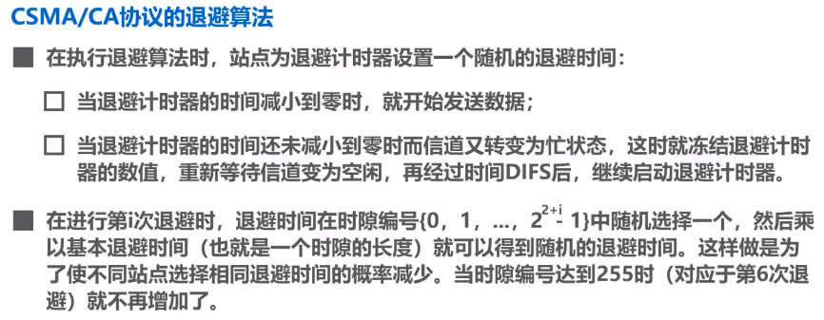

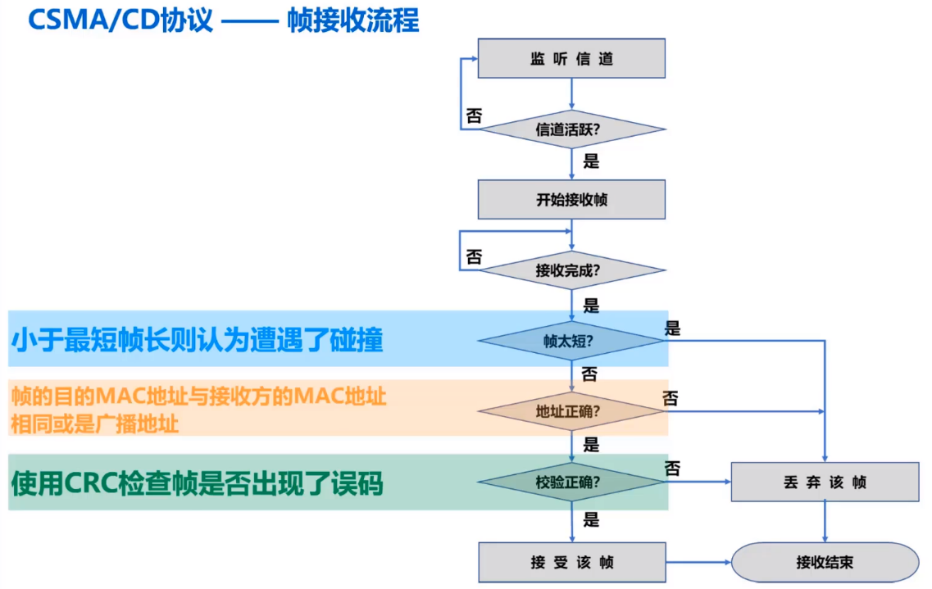0